APPENDIX D

PUBLIC SCOPING

SCOPING PROCESS

The purpose of the scoping process, as outlined in the Council on Environmental Quality (CEQ) regulations for implementing NEPA (40 CFR 1501.7), is to determine the scope of issues to be addressed in the EA/EIS and to identify significant issues relating to the action being proposed. The lead agency is required to invite input from Federal, State, and local agencies, affected Indian tribes, project proponents, and other interested parties (Section 1501.7 (a)(1)). Scoping is required for all EAs prepared by the NPS.

To satisfy scoping requirements for this proposed action, three public meetings were held, in Dover, Tennessee and Murray, Kentucky, on May 29, 2002, and again in Dover on June 27, 2002. Approximately 110 people attended the meetings on May 29, and about 40 people the subsequent meeting. An invitation to the June 27 scoping meeting at the Stewart County Public Library in Dover was sent out by a cooperating partner with the NPS, the West Kentucky Corporation (Figure D-1). Figure D-2 is a photograph depicting attendees at the June 27, 2002 scoping meeting.

Comments and questions were made at the meeting. No written comments were received, although NPS staff took notes, which are contained in Section 5. A web site called “Saving Fort Heiman” has been set up on the World Wide Web by the Fort Heiman friends group at http://www.thinkwestkentucky.com/fortheiman/ .

NPS sent out a letter of thank you to participants (Figure D-3) and continues to cooperate with state and local governmental agencies as well as the local non-profit group supporting protection of Fort Heiman.
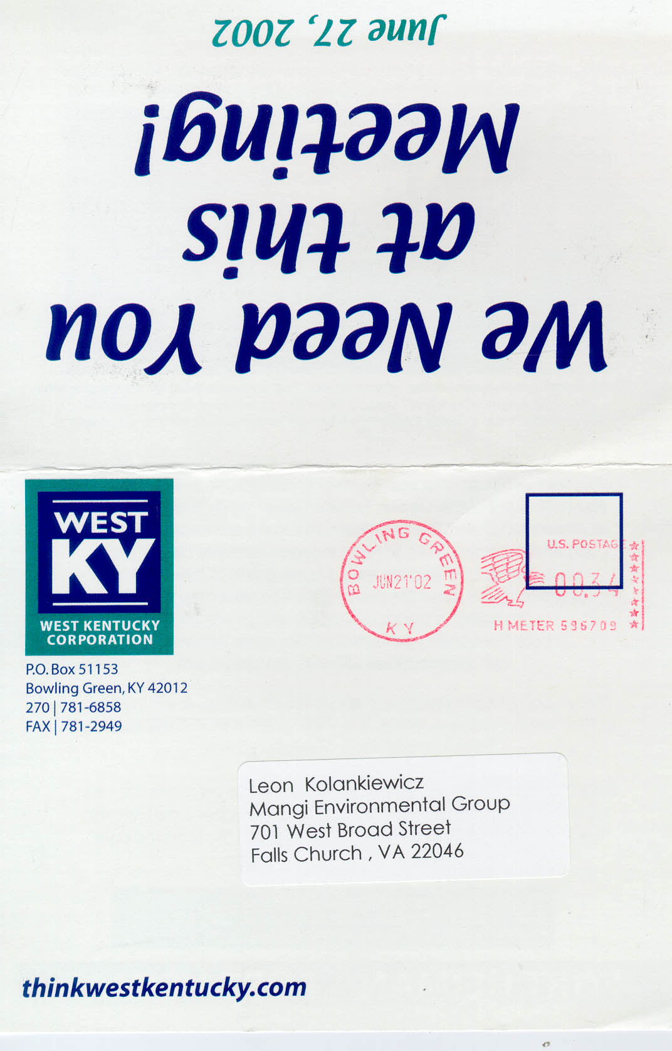

Figure D-1a. Invitation to June 27, 2002 scoping meeting

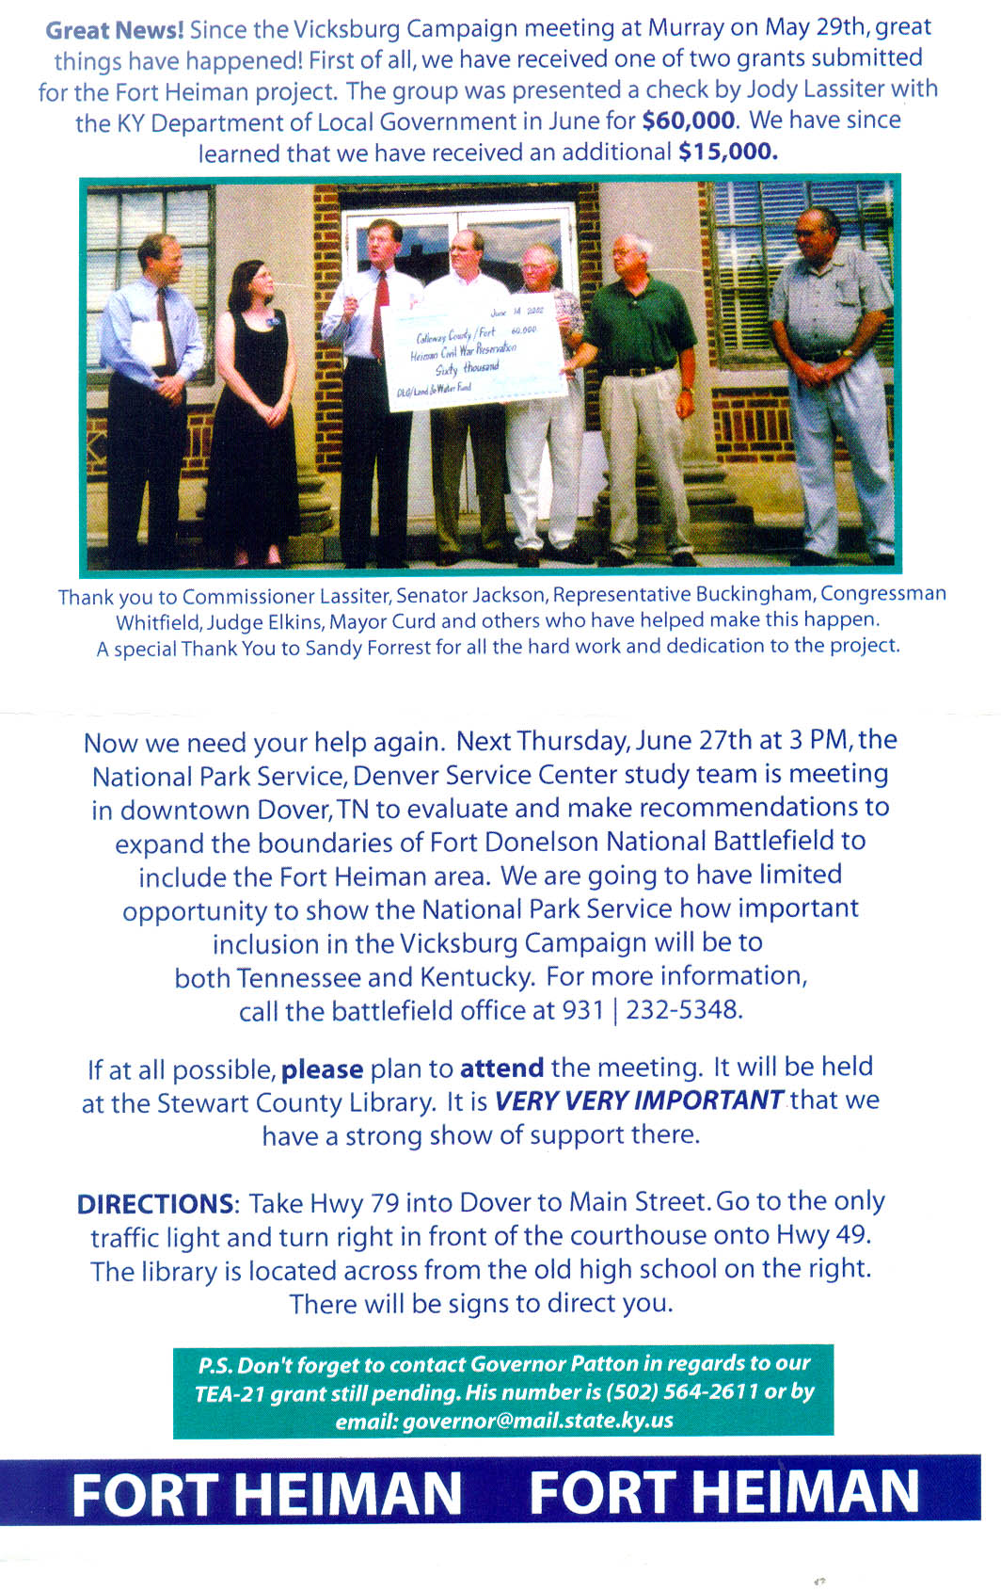

Figure D-1b. Invitation to June 27, 2002 scoping meeting (back side)

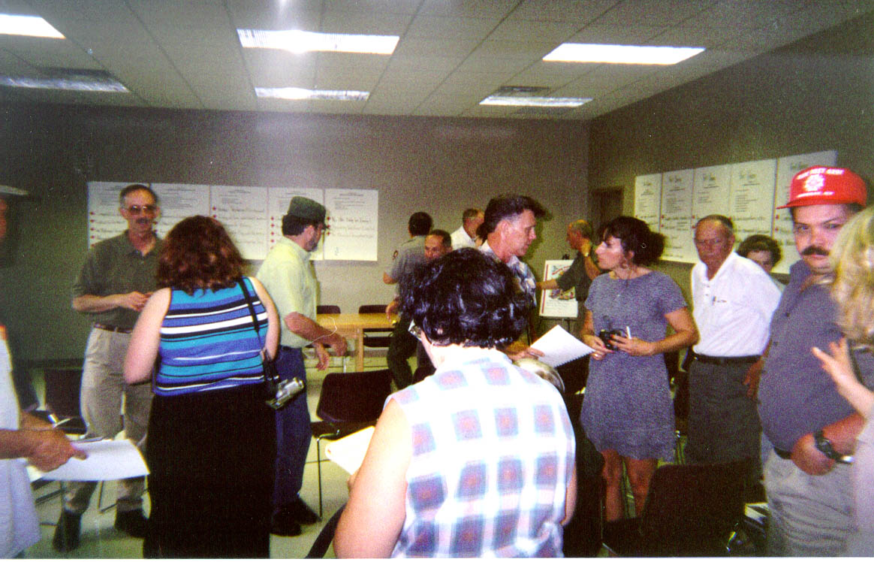

Figure D-2 – June 27, 2002 scoping meeting at Stewart County Public Library
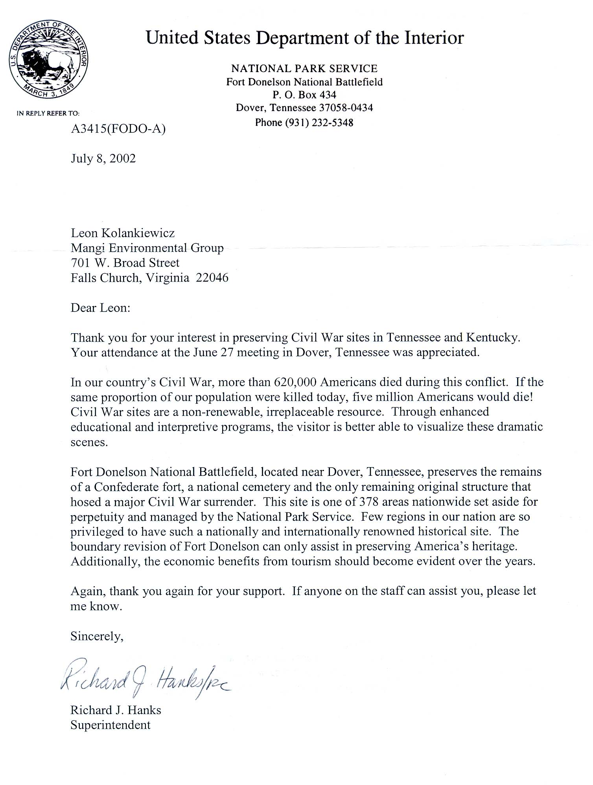
Figure D-3. Thank you letter from FODO superintendent to
scoping meeting participants

APPENDIX E

COMMENTS ON THE DRAFT EA

PUBLIC REVIEW OF THE DRAFT EA

A copy of this Draft EA was sent to all persons who requested a copy during the scoping process, as well as to other pertinent agencies and individuals potentially affected by the Proposed Action. This Draft EA will be available for public review for a minimum of 30 days. During this public review period, written comments on the EA are invited from the public and interested agencies. All comments received on the Draft EA will be reviewed by multiple parties, and appropriate responses will be prepared. Comments determined to be relevant to the project will be incorporated into the Final EA.

All comments and/or questions regarding the project or the Draft EA can be directed to:

Richard J. Hanks, Superintendent
Fort Donelson National Battlefield
P.O. Box 434
Dover, TN 37058-0434

After the 30-day public review period, the NPS will determine if the proposed action is significant enough to prepare an environmental impact statement (EIS). If an EIS is not required, the Regional Director of the NPS will sign a Finding of No Significant Impact (FONSI), which describes the selected alternative, why it was selected, and why it will have no significant impacts. The EA and FONSI together will conclude the NEPA compliance for this project.

APPENDIX F

Visitation Statistics from Similar Civil War and Military History
Themed National Parks

Visitation Statistics from Similar Civil War and Military History
Themed National Parks

Although it is not possible to accurately forecast visitation at Fort Heiman, were it to be added to FODO, it is possible to get a rough estimate of potential visitation by examining visitation figures from similar units. Table F-1 displays recent visitation figures for 36 Civil War and Revolutionary War-related national and state historic parks. All of the parks in the sample are located in the Delta and Deep South States. Only parks in which the main attraction was military-related were included. Several state parks were not included in the sample for this reason. There may be a historic fort, for instance, but other recreational components also attract many visitors, meaning visitation to the park is not solely to see the historical site. If the two types of visits could not be separated, the park was not included in the analysis. For example, Fort Macon in North Carolina has a Civil War fort, but also contains a beach on the Atlantic Ocean.

Table F-1. Historic Military-Related National and State Parks in the Southern U.S.
Park Name | State | Annual Visitation  (1999 or 2000) | Acreage | Miles from Interstate | Miles from City with Population > 50,000 | Visitor's Center or Museum | Battlefield | Civil War Significance | NPS
Horseshoe Bend NMP | AL | 125,372 | 2,040 | 60 | 65 | Y | Y | Y | Y
Fort Toulouse SP | AL | 212,439 | 340 | 14 | 10 | Y | N | N | N
Fort Morgan HS | AL | 92,453 | 480 | 65 | 40 | Y | N | Y | N
Historic Blakely SP | AL | 40,000 | 1,000 | 7 | 10 | N | Y | Y | N
Confederate Memorial Park | AL | 37,477 | 102 | 13 | 48 | Y | N | Y | N
Chickamauga & Chattanooga NMP | GA | 838,350 | 8,129 | 5 | 10 | Y | Y | Y | Y
Kennesaw Mountain NB Park | GA | 1,341,712 | 2,884 | 5 | 10 | Y | Y | Y | Y
Andersonville NHS | GA | 167,373 | 495 | 30 | 20 | Y | N | Y | Y
Pickett's Mill Battlefield SHS | GA | 10,000 | 765 | 15 | 20 | Y | Y | Y | N
Fort Morris SHS | GA | 13,000 | 67 | 7 | 20 | Y | N | N | N
Jefferson Davis Memorial SHS | GA | 25,000 | 13 | 19 | 55 | Y | N | Y | N
Fort McAllister Historic Park | GA | 56,000 | 1,700 | 9 | 25 | Y | N | Y | N
Abraham Lincoln Birthplace | KY | 236,180 | 117 | 3 | 55 | Y | N | Y | Y
Fort Munfordville | KY | 6,000 | 218 | 2 | 70 | Y | Y | Y | Y
Columbus-Belmont SP | KY | 90,940 | 156 | 20 | 130 | Y | N | Y | N
Perryville Battlefield SHS | KY | 38,672 | 250 | 30 | 45 | Y | Y | Y | N
Mansfield SHS | LA | 6,264 | 44 | 10 | 35 | Y | Y | Y | N
Port Hudson SHS | LA | 27,389 | 909 | 1 | 15 | Y | Y | Y | N
Brices Cross Roads NB Site | MS | 8,000 | 1 | 70 | 50 | Y | N | Y | Y
Visitors Center, Natchez Trace Parkway, Tupelo | MS | 51,249 | 1 | 70 | 50 | Y | N | Y | Y
Vicksburg NMP | MS | 934,226 | 1,860 | 30 | 1 | Y | Y | Y | Y
Grand Gulf Military Monument Park | MS | 38,000 | 400 | 25 | 55 | Y | Y | Y | N
Guilford Courthouse NMP | NC | 822,948 | 221 | 5 | 1 | Y | Y | N | Y
Moores Creek NB | NC | 89,872 | 88 | 20 | 15 | Y | Y | N | Y
Almanace Battleground | NC | 12,032 | 40 | 6 | 20 | Y | Y | N | N
Bentonville Battleground | NC | 30,000 | 240 | 6 | 30 | Y | Y | Y | N
Cowpens NB | SC | 212,876 | 842 | 5 | 35 | Y | Y | Y | Y
Ninety Six NHS | SC | 28,492 | 989 | 25 | 25 | Y | N | N | Y
Fort Sumpter National Monument | SC | 319,147 | 195 | 1 | 1 | N | N | Y | Y
Kings Mountain NMP | SC | 257,499 | 3,945 | 20 | 10 | Y | Y | N | Y
Stones River NB | TN | 186,212 | 714 | 30 | 1 | Y | Y | Y | Y
Andrew Johnson NHS | TN | 59,587 | 17 | 60 | 15 | Y | N | Y | Y
Fort Donelson NB and Cemetery | TN | 219,049 | 552 | 40 | 30 | Y | Y | Y | Y
Shiloh NMP | TN | 261,472 | 3,973 | 50 | 50 | Y | Y | Y | Y
Fort Pillow State Historic Park | TN | 48,000 | 1,642 | 35 | 65 | Y | Y | Y | N
Sycamore Shoals | TN | 275,000 | 50 | 10 | 55 | Y | N | N | N

Legend:

NMP = National Military Park; SP = State Park; (N)or (S)HS = (National) or (State) Historic Site; NB = National Battlefield

Y = Yes; N= No
Sources: NPS, 2000a; Bailey, 2001; Baker, 2001; Bangert, 2001; Blakely, 2001; Boehringer, 2001; Brown, 2001; Dalton, 2001; Flirt, 2001; Fraering, 2001; Games, 2001; May, 2001; McCloud, 2001; Parker, 2001; Standbridge, 2001; Taylor, 2001b; Winchester, 2001

